
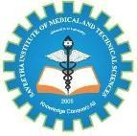
SIMATS ENGINEERING

Saveetha Institute of Medical and Technical Sciences Chennai- 602105

Student Name: P. Sunayana Reg. No.:192424303
Course Code: DSA0216 Slot: B
Course Name: Computer Vision with Open CV for modern AI
Course Faculty: Dr. Senthilvadivu S and Dr. T Kumargurubaran

Smart Dermatology Assistant using AI and Image Processing
Module Photographs: (3 photographs –Module Photo, Individual student contribution module work in the project and presentation image)
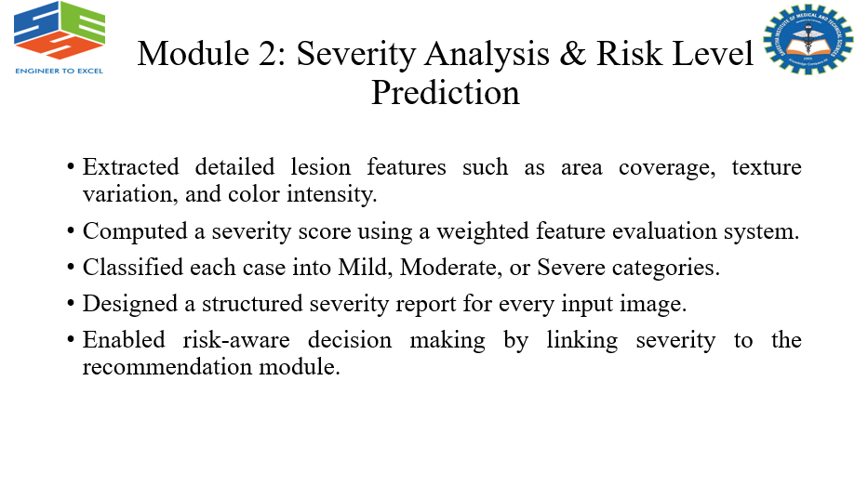
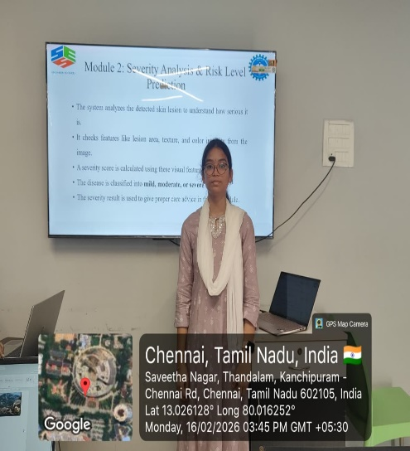
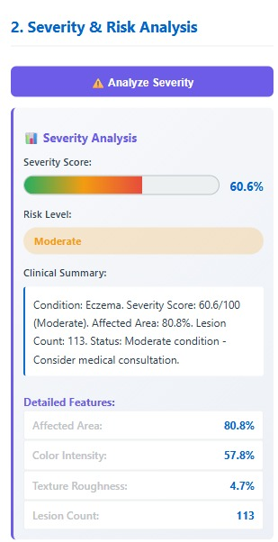
Project Description: (here you write what you did in this project (contribution) including Model Description
The Severity Level Prediction module in the Smart Dermatology Assistant using AI and Image Processing evaluates the seriousness of a detected skin disease after classification by analyzing lesion features such as size, color variation, texture, shape irregularity, and spread. Using machine learning or deep learning models, the system categorizes the condition into mild, moderate, or severe levels, helping to understand disease progression and urgency. This module supports early diagnosis, guides treatment recommendations, and assists both patients and dermatologists in deciding whether home care, specialist consultation, or immediate medical attention is required, thereby improving accuracy and efficiency in skin disease management.

Student Signature Guide Signature

